

**International Journal of ChemTech Research**

**CODEN( USA): IJCRGG ISSN : 0974-4290**

**Vol.5, No.5, pp 2630-2635, July-Sept 2013**

**A Simple And Validated RP-HPLC Method For The Estimation Oflevosulpiridein Bulk And Tablet Dosage Form**

**M.P.Mahajan*, S.D.Sawant, Y.B Deulgaonkar**

**Department of Pharmaceutical Chemistry,**

**Smt. Kashibai Navale College of Pharmacy Kondhwa (Bk) Pune-48, India.**

**\*Corres. Author: m_p_mahajan@yahoo.co.in**

**Mobile No.-9850273807**

**Abstract:** A novel, simple and economic reverse phase high performance liquid chromatography (RP-HPLC) method has been developed for the estimation of Levosulpiride (LEVO) in bulk and tablet dosage form with greater precision and accuracy. Separation was achieved on C18 column (250X4.6mm i.d., 5μm) in isocratic mode with mobile phase consisting of methanol, acetonitrile in the ratio of 80:20(v/v) at a flow rate 1 mL/min. The detection was carried out at 289nm. The retention time of Levosulpiride was found to be 3.11 min.The method was validated as per ICH guidelines. Validation studies demonstrated that the proposed RP-HPLC method is simple, specific, rapid, reliable and reproducible. The high recovery and low relative standard deviation confirm the suitability of the proposed method for the estimation of the drug in bulk and tablet dosage.

**Key words:** Levosulpiride, HPLC, Validation, ICH guidelines.

**Introduction**

Levosulpiride (LEVO) is a Dopamine D2 receptor antagonist. It is an antipsychotic and prokinetic agent. Levosulpiride is also claimed to have mood elevating properties. Levosulpiride is used in the treatment of psychoses, particularly negative symptoms of schizophrenia, anxiety disorders, dysthymia, vertigo, dyspepsia, irritable bowel syndrome and premature ejaculation. It is the (*S*)-enantiomer of sulpiride. Compared with racemic and dextro forms, the levo form of sulpiride has greater anti dopaminergic activity, anti-emetic and antidyspeptic effects and lower acute toxicity. It is chemically known as *n*-{[(2*s*)-1- ethylpyrrolidin-2-yl]methyl}-2-methoxy- 5-sulfamoyl benzamide (Fig-1)[2, 3]



**Fig-1 Chemical structure of Levosulpiride**

Literature survey reveals that one Spectrophotometric method [2], One HPLC methods have been developed for the estimation of Levosulpiride in bulk and tablet formulation. The objective of the present work was to develop simple, rapid, accurate, specific and economic RP-HPLC method for the estimation of Levosulpiride in bulk and tablet.

**Materials And Methods4-9**

**Reagents and chemicals**

Levosulpiride (LEVO) was supplied as a gift sample by Ajantha Pharma Mumbai. All the chemicals used were of HPLC grade purchased from E. Merck India Limited and bidistilled water was used for whole experiment. Levipride, a commercial formulation containing LEVO (50 mg) manufactured by Intas Pharmaceuticals Ltd. was purchased from local firms.

**Instrument:**

A Jasco HPLC system (Japan) composed of an PU-2080 plus pump equipped with a 7725i Rheodyne (CA, USA) injector, an UV-2075 plus UV–vis detector and a LC-Net II/ADC with inbuilt Borwin software was used for the study.

**Preparation and Selection of mobile phase**

The preliminary isocratic studies on a reverse phase C18 column with different mobile phase combination of Acetonitrile, methanol were studied for drugs. The optimal composition of mobile phase determined. Methanol:Acetonitrile (80:20 v/v) and filtered through 0.45μ membrane filter. The System suitability parameters are given in table-1.

**Preparation of standard solution**

The standard solution was separately prepared by dissolving the 50 mg of LEVO in 50 ml of Mobile Phase to get Standard stock solution of concentration of 1000 μg/mL. Further dilutions were made from the standard stock solution to get concentration of 50 μg/mL of LEVO. (Fig-2).The results for Assay are summarized in table-2.

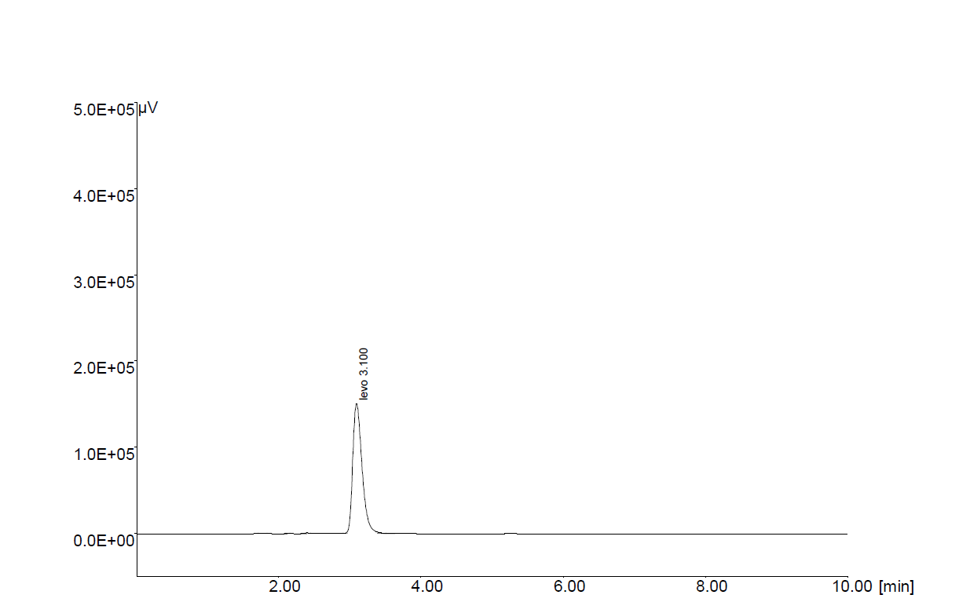

**Fig-2: Chromatogram of standard solution of Levosulpiride.**

**Table 1: System suitability parameters.**

|  |  |  |
| --- | --- | --- |
| **Sr. No.** | **Parameters** | **Levosulpiride** |
| 1. | Retention time (min) | 3.11 |
| 2. | No. of theoretical plates | 2890 |
| 3. | Tailing factor | 1.21 |
| 4. | LOD (μg/ mL) | 12.13 |
| 5. | LOQ(μg/ mL) | 36.76 |

**Table 2: Results of assay from tablet dosage form.**

|  |  |  |  |
| --- | --- | --- | --- |
| **Drug** | **Label claim/tab. (mg)** | **Amount found (mg)** | **% Label Claim** |
| Levosulpiride | 50 mg | 49.69 mg | 99.38 |

**Preparation of sample**

Twenty tablets were finely powdered and an accurately weighed sample of powdered tablets equivalent to LEVO (75 mg) was transferred to a 50 mL volumetric flask and dissolved in mobile phase. The solution was shaken well and allowed to stand for 15 min with intermittentsonication to ensure complete solubility of drug. The contents were made up to the mark with Mobile Phase and filtered through a 0.45μ membrane filter. From the filtrate, dilution was made in a 10 mL volumetric flask to get 50μg/ mL of Levosulpiride with mobile phase. (Fig-3).

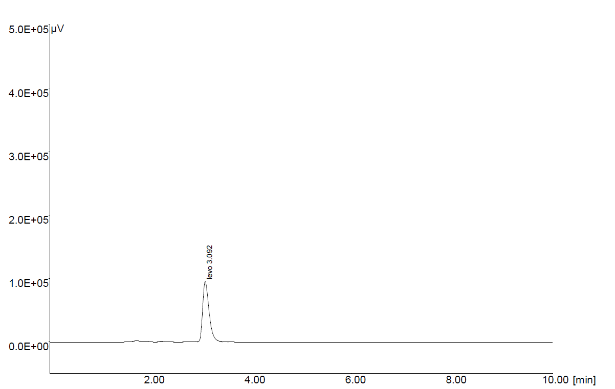

**Fig-3: Chromatogram of tablet formulation.**

**Method validation**

As per the International Conference on Harmonization (ICH) guidelines. The method validation parameters such as specificity, linearity, precision, accuracy, limit of detection/quantization and robustness were optimized.

**Linearity**

To establish linearity, the stock solutions was prepared (1000 μg/mL of LEVO) using Mobile Phase as the solvent, again from the stock solution further dilutions were made to yield solutions in the concentration range of 25-150 μg/mL (LEVO) using Mobile Phase as a diluent.The mobile phase was filtered through a 0.45 μm membrane filter and delivered at 1.0 mL/minfor column equilibration; the baseline was monitored continuously during this process. The prepared dilutions were injected in series, peak area was calculated for each dilution, and concentration was plotted against peak area. The coefficient of regression, equation of regression line obtained from the calibration curve (Fig 5) is shown in the table-3.

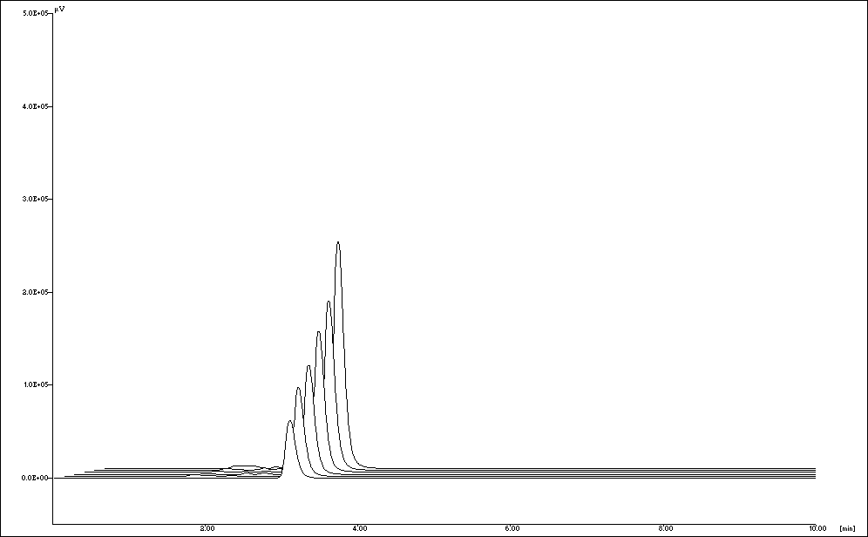

**Fig-4: 3D -Overlain chromatogram of standard solutions of Levosulpiride.**

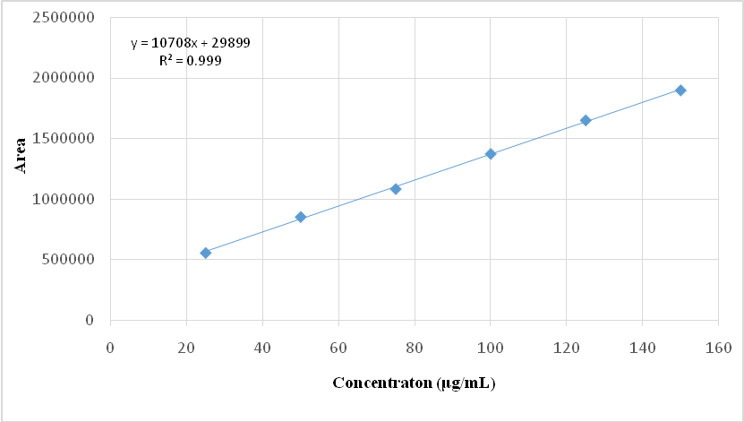

**Fig-5: Calibration curve of Levosulpiride.**

**Table 3: Linearity results of Levosulpiride**

|  |  |
| --- | --- |
| **Parameters** | **Levosulpiride** |
| **Linearity range (µg/ml)** | 25-150 |
| **r2** | 0.9994 |
| **Slope** | 10708 |
| **Intercept** | 298990 |

**Precision**

Precision was determined as both repeatability and intermediate precision, in accordance with ICH recommendations. Repeatability of sample injection was determined as intra-day variation and intermediate precision was determined by measurement of inter-day variation. For both intra-day and inter-day variation, solutions of LEVO at single concentration of 50μg/mL was determined. The results of precision are summarized in table-4.

**Accuracy**

Accuracy was determined by the standard addition method. Preanalyzed samples of LEVO (50μg/mL) were spiked with 80, 100, and 120% extra LEVO standard and were analyzed by the proposed method. The experiment was performed in triplicate. Recovery (%) was calculated for each concentration. The results of accuracy are summarized in table-5.

**Limit of detection (LOD) and limit of quantitation (LOQ)**

Six replicates of the analyte were analyzed and quantified. The limit of detection and limit of quantitation was found to be 12.13μg/mL and 36.73μg/mL for LEVO respectively.

**Robustness**

The robustness of the method was determined to assess the effect of small but deliberate variation of the chromatographic conditions. Robustness was determined by changing the mobile phase flow rate to 0.9 and 1.1 mL/ min and the concentration of methanol in the mobile phase to 48 and 52%. The results are summarized in table-6.

**Table 4: Result Analysis of Precision Studies**

|  |  |  |
| --- | --- | --- |
| **Drug** | **% RSD (intraday)** | **% RSD (inter day)** |
| Levosulpiride | 0.263 | 0.567 |

**Table 5: Result of Recovery Studies Levosulpiride**

|  |  |  |  |  |
| --- | --- | --- | --- | --- |
| Recovery Level (%) | Drug | Conc. of drug (μg/ml) | | % Recovery |
| **Drug Taken** | **Std. drug added** |
| **80** | LEVO | 50 | 40 | 98.96 |
| **100** | 50 | 50 | 99.50 |
| **120** | 50 | 60 | 99.86 |

**Table 6: Robustness of the method**

|  |  |  |  |
| --- | --- | --- | --- |
| **System suitability parameters** | **Normal condition** | **Change in**  **condition** | **Change in % RSD** |
| Flow Rate | 1.0 mL/min | 0.9 mL/ min  1.1 mL/min | 0.033  0.028 |
| Mobile phase ratio (Methanol: Acetonitrle) | 80:20 | 78:22  82:18 | 0.043  0.033 |

**Results And Discussion**

The HPLC procedure was optimized with a view to developing a method. From several solvents and solvent mixtures investigated methanol acetonitrile (80:20 v/v) was found to furnish sharp, well-defined peak with very good symmetry. Various other mobile phases tried earlier either did not give well defined peak in a short time, therefore were not considered. The final selection on mobile phase composition and flow rate was made on the basis of peak shape (peak area, peak asymmetry & tailing factor), baseline drift, time required for analysis, and cost of solvent, and methanol, acetonitrile (80:20v/v) was selected as the optimum mobile phase and the retention time of LEVO was found to be 3.11 min .Quantitative linearity was obeyed in the concentration range of 25-150μg/mL for LEVO. The linear regression data for the calibration plot are indicative of a good linear relationship between peak area and concentration over a wide range. The linear regression equation was found to be y = 10708x(r² = 0.999) for LEVO (shown in Fig-4). The correlation coefficient was indicative of high significance. The low values of the standard deviation, the standard error of slope, and the intercept of the ordinate showed the calibration plot did not deviate from linearity. There were no significant differences between the slopes of standard curves constructed on different days which indicates the sensitivity of the method. The high percentage recovery indicates that the proposed method is highly accurate. No interfering peaks were found in the chromatogram showing that excipients used in tablet formulations didn’t interfere with the estimation of the drug by the proposed HPLC method.

**Conclusion**

A new isocratic RP-HPLC method has been developed for the estimation of Levosulpiride. Statistical analysis of the results has been carried out revealing high accuracy and good precision. The method was found to be simple, accurate, economical and rapid and they can be applied for routine analysis in laboratories.

**Acknowledgements**

Authors are thankful to Ajantha Pharma, Mumbaifor providing the gift sample of Levosulpiride forcarrying the research work. The authors are also thankful to the management, Sinhgad Technical Education Society’s, Smt. Kashibai Navale College of Pharmacy, Kondhwa (Bk.), Pune-48, for providing excellent research facilities.

**References**

1. The Merck Index-An Encyclopedia of Chemicals, Drugs andBiologicals (14thedition), Merck Research Laboratories, Whitehouse Station, New Jersey,USA,2006.
2. Brahmbhatt D.D, Patel M. B., Patel J.C. Development and validation for Estimation of Levosulpiride by Area Under Curve and Difference Spectrophotometric Method International Journal of ChemTech ResearchVol.4, July-Sept 2012, 945-950.
3. Agrawal Y.P, Gautam S.P, Verma A., Agrawal M.Y., Gupta A.K. Simultaneous estimation of esomeprazole and levosulpiride in solid dosage form Pelagia Research Library 2012 (3):337-342.
4. Manjunath S., Chouhan V., S.Sandeep Spectrophotometric Estimation of Levosulpiride In Bulk Drug And Formulations International Journal of Pharmacy and Pharmaceutical SciencesVol 3, Issue 2, 2011, 135-137.
5. Jain M.S., Agrawal Y.S., Chavhan R.B., Bari M.M., Barhate S. D. UV Spectrophotometric Methods for Simultaneous Estimation of Levosulpiride and Esomeprazole in Capsule Dosage Form Asian Journal of Pharmaceutical Analysis; Vol. 2: Issue 4, 2012,106-109.
6. S. Shilpa, T. Sai Annapurneswari, V. Jayathirtha Rao, B. Rajesh, P.Venkateshwarao, B. China RajuSimultaneous Estimation and Validation of Levosulpiride and Rabeprazole Sodium in Bulk and Pharmaceutical Dosage Form by RP-HPLC Method Journal of Pharmacy Research,5(10),2012,5010-5013.
7. ICH Harmonized Tripartite Guideline Validation of Analytical Procedures: Text and Methodology, Q2 (R1) November, 2005, 1-17.
8. Sethi P. D., High Performance Liquid Chromatography, Quantitative Analysis of Pharmaceutical Formulations, 1st edition, CBS Publishers and Distributors, New Delhi,2001,3-11, 116-120.
9. Lloyd R. Snyder. Joseph j. Kirkland, Practical HPLC Method Development, 2nd Edition, John Wiley & Sons, INC, 266-288.

**\*\*\*\*\***