|  |  |
| --- | --- |
| Description: c | **International Journal of ChemTech Research**  **CODEN (USA): IJCRGG, ISSN: 0974-4290, ISSN(Online):2455-9555**  **Vol.11 No.06, pp 293-304, 2018** |

**Synthesis, Growth and Characterization Studies of**

**Novel Semi Organic Nonlinear Optical Bisthiourea lithium oxalate single crystals**

**T.Kavitha1*, G. Pasupathi2, N.Kanagathara3**

**1Department of Physics, Arasu Engineering College, Kumbakonam - 612501, India**

**2PG and Research Department of Physics, AVVM Sri Pushpam College (Autonomous)**

**Poondi, Thanjavur- 613 503, Tamilnadu, India**

**3Department of Physics, Jaya Engineering College, Thiruninravur, Chennai – 602 024, India**

**Abstract :** Optically good quality single crystals of novel semi organic material, bisthiourea lithium oxalate (BTLO) have been grown from aqueous solution by slow evaporation technique. The lattice parameters for the grown crystals were determined by the single crystal X-ray diffraction analysis. The presence of functional groups was estimated qualitatively by using Fourier Transform Infra-red (FT-IR) and Raman analysis. The UV-Vis studies have been carried out and the cut off wavelength λ is found to be 295 nm. The energy gap is calculated as 3.217 eV. Mechanical strength of the title compound was analyzed by Vicker’s micro hardness tester. The thermal stability of BTLO was studied by TGA/DTA thermal analyzer. The nonlinear optical property of the grown crystal was confirmed by Kurtz-Perry powder technique and hence suggests that the grown crystal was well suited for nonlinear optical applications.

**Keywords** : Crystal growth, FT-IR, FT Raman, Thermal studies, Micro hardness, SHG.

**1. Introduction**

Most of the nonlinear optical (NLO) materials are currently used in the fabrication of passive and active photonic devices [1, 2]. In the past few years, the characterization study of semi organic NLO materials has a hot spot for chemistry and physics scholars due to their potential applications such as optical devices, parametric oscillators, frequency doublers etc., [3-5]. In general the optical applications depend upon various properties of the materials such as percentage of transparency, birefringence, refractive index, dielectric constant, thermal, mechanical and photochemical stability. Recently, there has been a widespread interest to grow the metal-organic single crystals based on the advantages of the inorganic and organic compounds. In this class of materials, the organic ligand is ionically host, thereby improved mechanical and thermal properties.

**T.Kavitha *et al* /International Journal of ChemTech Research, 2018,11(06): 293-304.**

**DOI=** [**http://dx.doi.org/10.20902/IJCTR.2018.110638**](http://dx.doi.org/10.20902/IJCTR.2018.110638)

**T.Kavitha *et al***/International Journal of ChemTech Research**,** 2018,11(06): 293-304. 294

Based on those considerations, it is essential to search the new nonlinear optical materials for the opto-electronic and other NLO applications.

The extensive search for new types of NLO materials like thiourea and its derivatives has excellent physical and chemical properties for those applications [6-11]. In this article, one such semi organic thiourea family crystal namely bis thiourea lithium oxalate has been developed and the grown crystals were characterized by single crystal X-ray diffraction analysis, vibrational studies, NMR studies, optical transmittance and mechanical studies, second harmonic generation test (SHG) etc., The result are presented and discussed in detail in this communication.

**2. Crystal growth**

Bisthiourea lithium oxalate (BTLO) single crystals were grown by dissolving thiourea (AR-Grade), Lithium sulphate and oxalic acid (GR-grade) in stoichiometric ratio 2:1:1 using deionized water. The prepared solution was stirred well up to 6h for the homogeneous mixer. Then the solution was allowed to evaporate at 50oC. After the period of 10 days, colorless salt was obtained and the salt was purified by repeated recrystallization process. A saturated solution of BTLO was prepared by double-distilled water. The solution was allowed to slow evaporation in the vibrational and dust free atmosphere. After the growth period of 25 days, colourless and transparent crystals were harvested and are depicted in Fig.1.

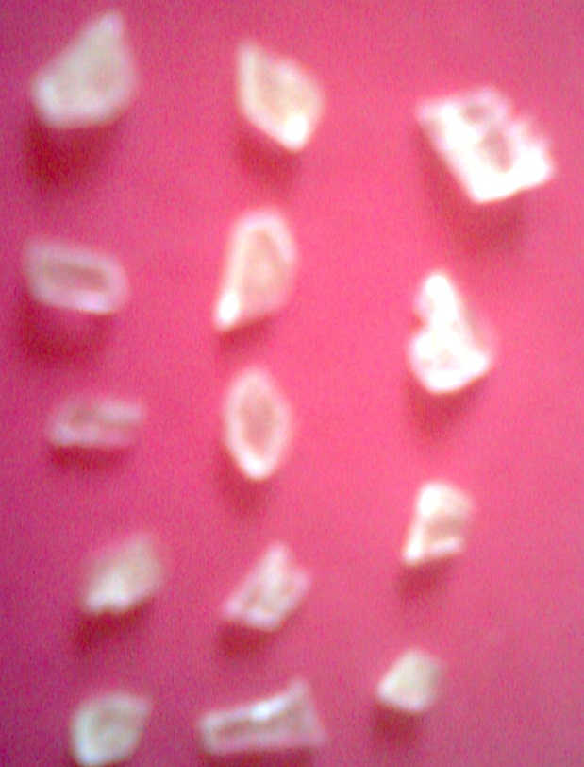

**Fig.1. As grown BTLO crystal**

**3. Results and discussion**

***3.1 Single crystal X-ray diffraction analysis***

The grown crystals of the title compound was subjected to single crystal XRD analysis using ENRAF Nonius AD4/MAC4 X-ray diffractometer with MoKα (λ=0.71073Ao) radiation. The single crystal XRD data of the title crystal indicates that it crystallizes in the triclinic system with space group P with lattice parameters a =3.420±0.006 Å; b= 5.082±0.0014 Å; c=6.155±0.011; α=78.52o; β=84.82o; γ=81.04o and volume V=103.4(Å) 3and these values very well matches with the earlier literature [10] and thus confirm the grown crystal. From these singlecrystalX-ray measurements, the lattice parameters were found and are presented in Table1. The synthesized compound crystallizes in triclinic crystal system. In order to understand the role of metal ions in the crystallographic properties of metal thiourea complexes, a comparison is made between free ligand thiourea.

**T.Kavitha *et al***/International Journal of ChemTech Research**,** 2018,11(06): 293-304. 295

**Table 1: Lattice cell parameters of BTLO single crystal**

|  |  |  |
| --- | --- | --- |
| **Sample name** | **Cell parameters** | **Crystal system** |
| Thiourea | a=7.66 Å | Orthorhombic |
| b=8.54 Å |
| c=5.52 Å |
| Lithium hydrogen oxalate | a=5.452 Å | TriclinicP1 |
| b=7.672 Å |
| c=8.562 Å |
| BTLO | a=3.420±0.006 Å | TriclinicP |
| b= 5.082±0.0014 Å |
| c=6.155±0.011 Å |

**3.2 FT-IR studies**

A Perkin Elmer Spectrum one FT-IR spectrometer was employed to record the IR spectrum to analyze the functional groups present in the crystals. The sample for this measurement was finely grounded and mixed with KBr .The characteristic vibration frequency of the functional groups present in the title crystals were assigned and tabulated in Table 2 and the spectrum is shown in Fig.2. The broad peaks with higher wavenumbers usually assigned to free and associated N-H stretching. These peaks observed at 3936, 3774 and 3682 cm-1 with medium intensity. The thiourea molecule has sulphur and two hydrogen atoms which are capable of having coordination with lithum atom and this will affect the N-H stretching frequencies in the present molecule. In general the N-H stretching frequencies of thiourea molecule observed in the region 3250 -3350 cm-1 and in the present case it is observed at 3310 cm-1 with medium intensity [7]. The broad peak with medium intensity at 1792 cm-1 is assigned to C=O stretching and 1679 cm-1 is assigned to C-O stretching [10]. The peaks at 1400 and 1339 cm-1 with medium intensity is assigned to C-N stretching [7]. It is observed C=S stretching vibration is shifted to 782 cm-1 in BTLO from 730 cm-1 of thiourea [6]. The strong peak at 667 cm-1 is assigned to N-C-S asymmetric bending [7]. The weak peak at 603 cm-1 is assigned to O-C=O in plane deformation [7]. The medium strong peak at 548 cm-1 is ascribed to N-C-S asymmetric bending [7]. The peaks at 538 and 510 cm-1 is assigned to N-C-N asymmetric bending [7].

**T.Kavitha *et al***/International Journal of ChemTech Research**,** 2018,11(06): 293-304. 296



**Fig.2 FT-IR spectrum of BTLO crystal**

**3.3 FT-Raman studies**

Raman spectral measurements were made with an FT-Raman Bruker RFS 27:/S Raman module with a resolution of 2 cm-1. An air cooled diode pumped Nd:YAG laser, operated at 1064 nm and a power output of 100mW was used as source. The spectrum was recorded over the range 3500-50 cm-1. The recorded FT-Raman spectrum is shown in Fig.3 and the vibration assignment is given in Table 2. The peaks at 3283, 3237 and 3183 cm-1 is assigned to N-H stretching [7]. The medium peak at 1383 cm-1 with medium intensity is assigned to C-N stretching. The medium peak at 1093 cm-1 with medium intensity is assigned to C-O stretching [7]. The strong peak at 733 cm-1 is assigned to C-S stretching [7,8,10]. The weak peak at 569 cm-1 is assigned to N-C-S asymmetric bending [7]. The medium strong peak at 478 cm-1 is assigned to N-C-N asymmetric bending [7,12].

**T.Kavitha *et al***/International Journal of ChemTech Research**,** 2018,11(06): 293-304. 297



**Fig.3 FTRaman spectrum of BTLO crystal**

**Table 1 Vibration band assignment of BTLO crystal**

|  |  |  |
| --- | --- | --- |
| **Wavenumbers (cm-1)** | | **Band assignment** |
| **FT-IR** | **FT-Raman** |
| 3310bw | 3283w | N-H stretching |
|  | 3237w | N-H stretching |
|  | 3183ms | N-H stretching |
| 1792mb |  | C=O stretching |
| 1679w |  | C-O stretching |
| 1400m |  | C-N stretching |
| 1339m | 1383m | C-N stretching |
| 1095w | 1093m | C-O stretching |
| 850s |  | C=S stretching |
| 782ms |  | C=S stretching |
| 721w | 733s | C=S stretching |
| 667s |  | N-C-S asymmetric bending |
| 603w |  | O-C=O in plane deformation |
| 548ms | 569w | N-C-S asymmetric bending |
| 538ms |  | N-C-N asymmetric bending |
| 510w | 478ms | N-C-N asymmetric bending |

**3.4 FT-NMR studies**

The 1H NMR and 13C NMR spectral analysis are the two important analytical techniques used to study the structure of organic compounds. In the present work, the 1H NMR and 13C NMR spectra of the grown crystal have been recorded using D2O as solvent on a Bruker Avance III 500 MHz spectrometer at 22oC to confirm the molecular structure of the grown crystal. The spectra are presented in Fig. 4 and 5 respectively. The signals due to N-H and COOH protons do not show up because of fast deuterium exchange taking place in these

**T.Kavitha *et al***/International Journal of ChemTech Research**,** 2018,11(06): 293-304. 298

two groups with D2O being used as the solvent [13-14]. Due to hygroscopic nature of the title crystal, strong intense water signal appears at 4.760 ppm. Amino groups (N-H) have an exchangeable proton. In NMR, Exchangeable protons give broad signals or almost completely disappear if the concentration is low [15]. Amino groups (N-H) in thiourea show weak signals at 2.164, 1.115 and 1.093 ppm. In From the 13C NMR spectrum, the signal at 164.60 ppm is due to carbonyl group of lithium oxalate. As no other peaks are observed, the compound has been successfully synthesized and it is a pure material.

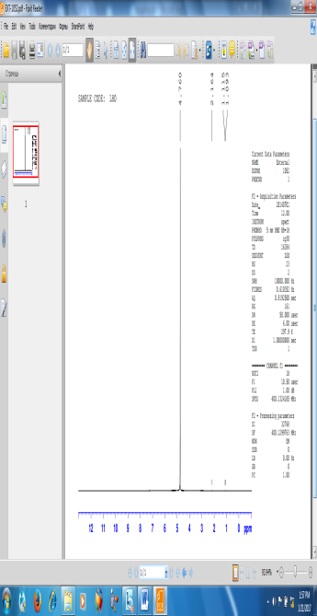

**Fig.4Proton NMR spectrum of BTLO crystal**

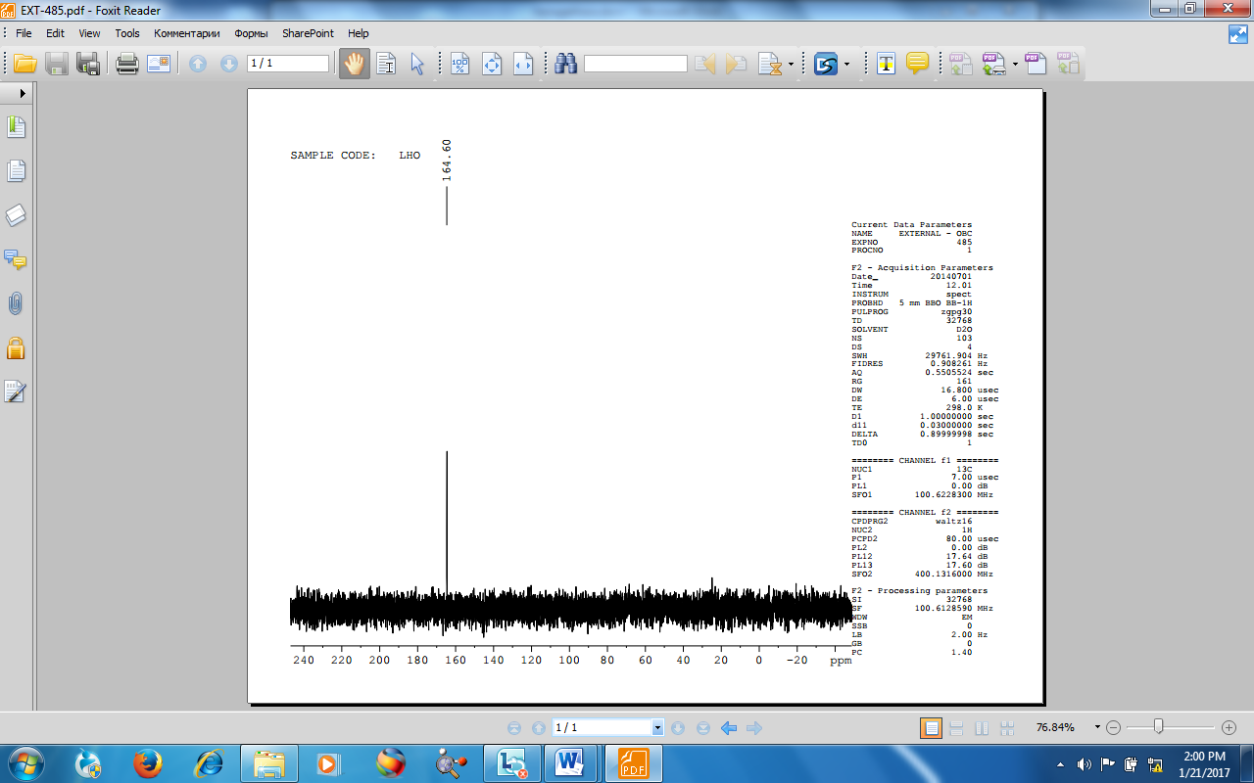

**Fig.5Carbon NMR spectrum of BTLO crystal**

**3.5 Optical absorption studies**

The UV-Vis-NIR spectrum gives information about the structure of the molecule because the absorption of UV and visible light involves the promotion of the electron in σ and π orbital from the ground state to higher energy states. Transmission spectral analysis is important for any NLO material because a non linear optical material can be of practical use only if it has wide transparency window. The UV-VIS-NIR transmittance spectrum is recorded using Perkin- Elmer- Lambda-35 spectrophotometer in the range of 190- 1100 nm and it is shown in the Fig.6. From the spectrum (Fig.6), it is evident that the title crystal has UV cut off wavelength at 295 nm which is sufficient for SHG laser radiation or other application in the blue region [16]. The transmittance percentage in the visible region is found to be 83 %. The grown BTLO crystals have a good transmittance and the lower cut off wavelength is nearly 295nm and upper cut off wavelength is 355 nm. The large transmittance in the entire visible region enables it to be a good candidate for opto-electronic applications [17]. Using the Tauc’s relation, a graph has been plotted between hν and (αhν)2 to estimate the direct band gap value, where α is the absorption coefficient and hν is the energy of the incident photonE=hν and it is shown in

**T.Kavitha *et al***/International Journal of ChemTech Research**,** 2018,11(06): 293-304. 299

Fig.7. The energy gap Eg is determined by extrapolating the straight line protion of the curuve to (αhν)2 =0. From the plot, the band gap of the grown crystal is found to be 3.217 eV.



**Fig.6 UV-Vis NIR transmittance spectrum of BTLO**



**Fig.7Tauc’s plot of BTLO**

**3.5 Microhardness study**

The good quality crystals are needed with good optical and mechanical properties [18,19]. Hardness is a physicochemical property that characterizes the state of the material under test and gives information on some specific features of the material such as the character of the chemical bonding. It is the resistance in which the material offers to indentation by a much harder body and may be termed as a measure of the resistance against lattice destruction or permanent deformation or damage. Microhardness studies have been applied to understand the plasticity of the crystals. It is nothing but the resistance offered by the material to the localized deformations caused by indentations. The hardness number (Hv) is measured by the ratio of applied load to the surface area of

**T.Kavitha *et al***/International Journal of ChemTech Research**,** 2018,11(06): 293-304. 300

indentation. To find surface hardness of the grown BTLO crystal was measured from 25g to 100g load using shamed 2a HMV-2 micro hardness tester. The transparent and smooth surface was selected for hardness measurement. It was carried out at room temperature and the time indentation is kept constant at 5s for all the loads. The hardness number of the material was calculated by the following relation



Where, *‘P’* is the applied load and *‘d’* is the mean diagonal length indentation.

A plot of logP vs logd gives a straight line(**Fig.8**), which is in good agreement with Meyer’s law. **Fig. 9** gives the Vicker’s microhardness profile as a function of the applied test loads and shows that the microhardness of the crystal increases with an increase of applied load. The work hardening coefficient ‘n’ should lie between 1 and 1.6 for hard materials and above 1.6 for soft materials [20].The work hardening coefficient ‘n’ was estimated from the slope of the straight line (**Fig.4.26**) and it is found to be 1.6 which suggest that BTLO belongs to the family of soft materials.

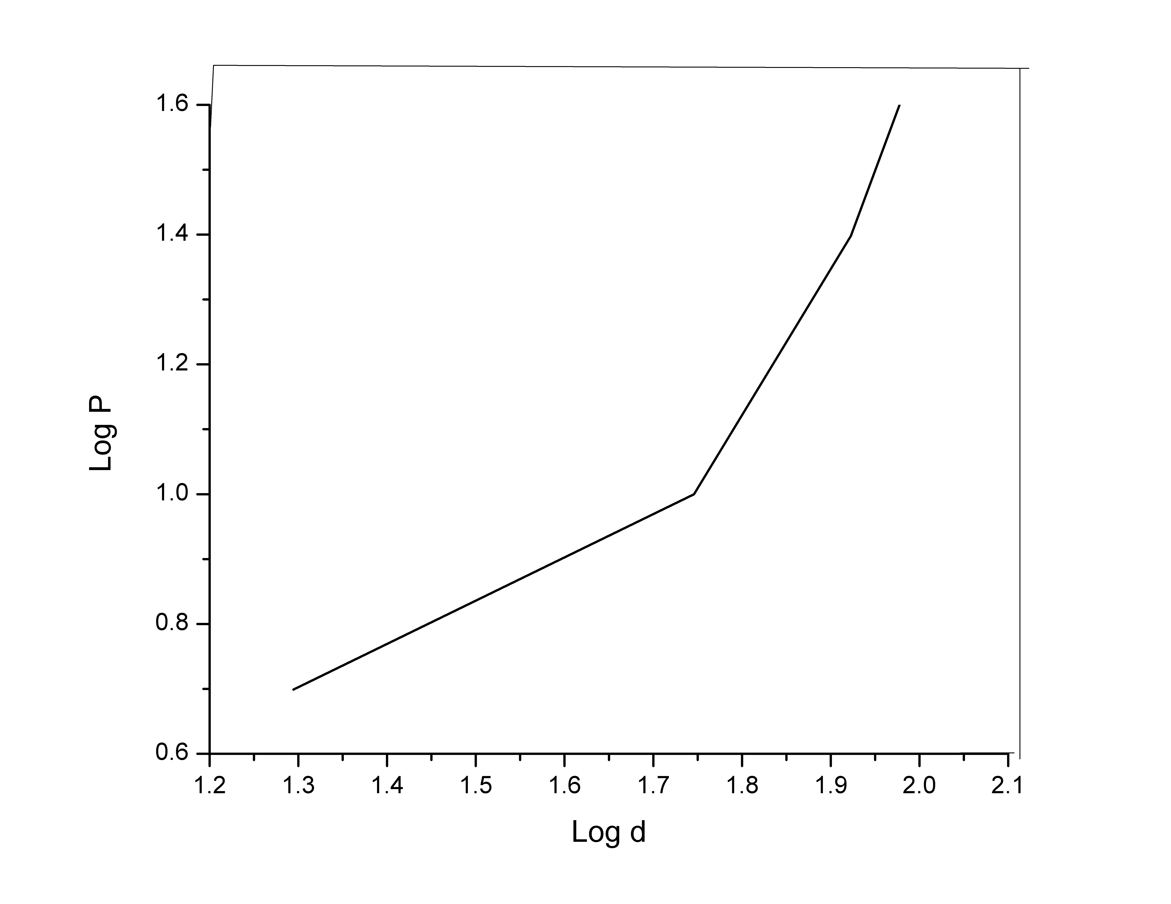

**Fig.8. Plot of log P vs. log d for BTLO crystal**

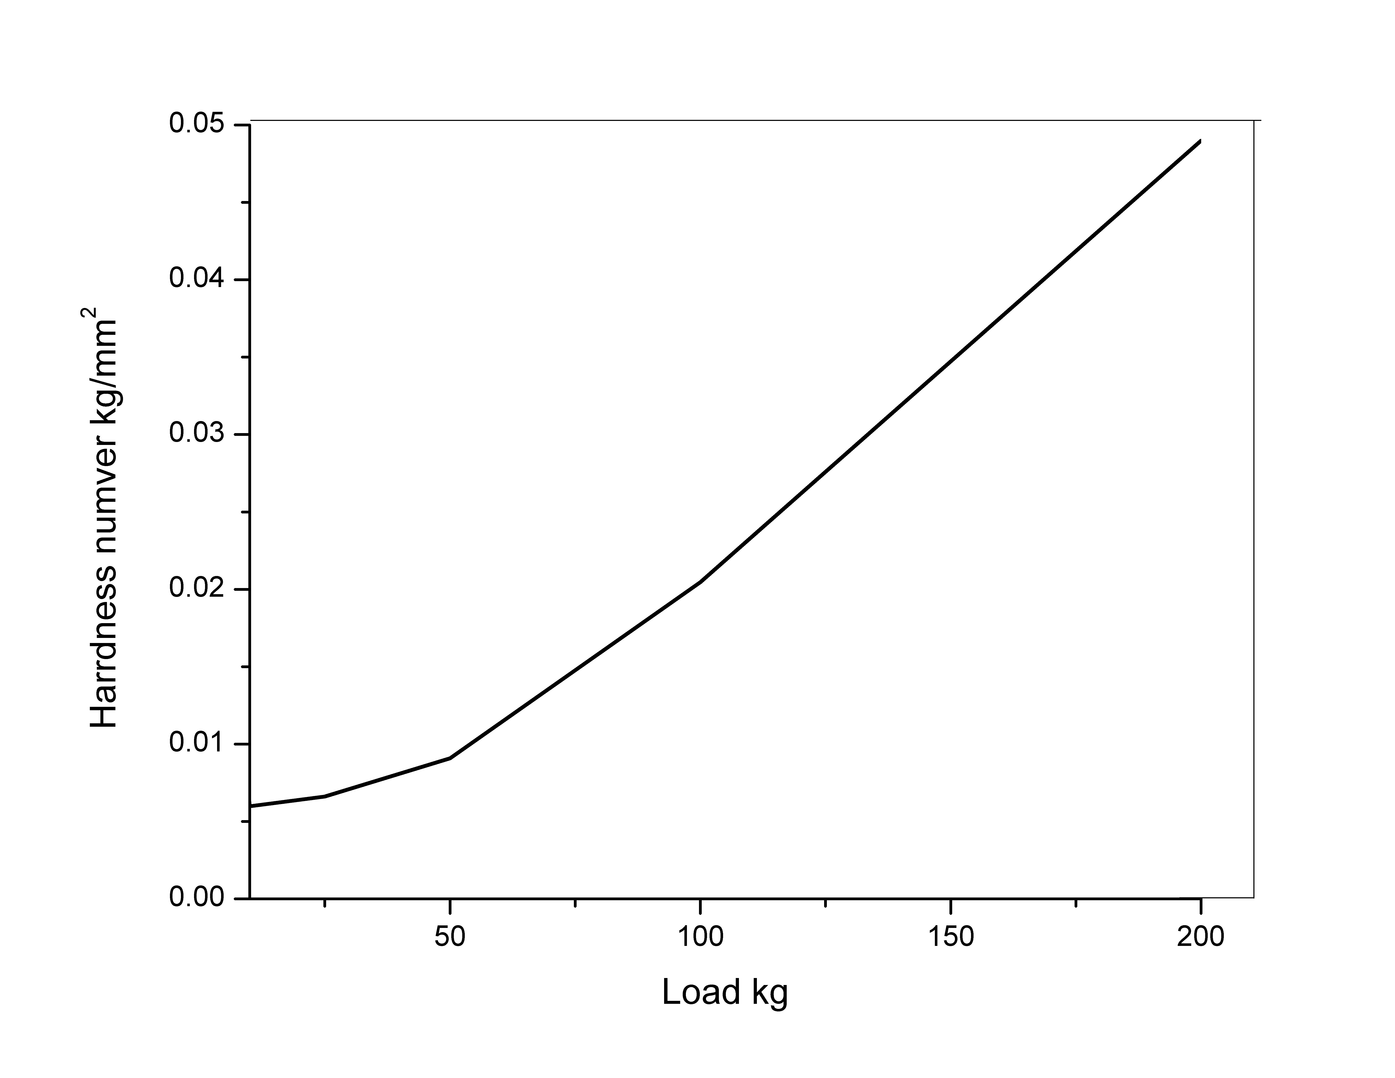

**Fig.9. Variation of Vicker’s Hardness with load**

**T.Kavitha *et al***/International Journal of ChemTech Research**,** 2018,11(06): 293-304. 301

**3.7 Thermal studies**

The thermal studies of BTLO are already reported by Martin Britto Dhas et al [10].   
TG-DTG curve of Lithium hydrogen oxalate hydrate (BTLO) at 20oC/min is shown in Figure. It is seen that thermal decomposition of BTLO occurs in four stages involving dehydration and decomposition. During the first stage of thermal decomposition water molecule is removed from the structure of the compound in the temperature range 120 to 168.19oC with a weight loss of 17.84%. The corresponding DTG peak occurs at 158.44oC. The second stage of decomposition occurs in the temperature range 223.19-256.83oC is accompanied by a major weight loss of 40.94% is due to the elimination of CO2 molecule and its DTG peak occurs at 245.67oC. The third stage of decomposition between the temperature range 488.23-523.62oC with a weight loss of 12.52% is attributed to the release of oxygen and accompanied by a DTG peak at 488.23oC and fourth stage of decomposition occurs in the temperature range 713.01-724.34oC is due to the evolution of carbon monoxide. Its DTG peak appears at 718.94oC. Finally, weight loss of 7.274% after 800oC is assigned to the elimination of lithium oxide from the structure of the compound with a final residue of 0.4329mg. The decomposition of BTLO is theoretically calculated and there is a very good agreement between the expected and observed weight percentage of BTLO compound.



**Fig.10. TGA/DTA curve of BTLO**

**3.6 Second harmonic generation study**

The second harmonic generation property of the grown TMPA crystal is analyzed by the Kurtz-Perry technique [21]. The Q-switched Nd-YAG laser operating at 1064 nm of pulse width 8ns at a frequency is illuminated on the powder sample. The output wave with the wavelength 532 nm confirms the SHG property of the grown crystals. The SHG efficiency of BTLO is compared with the reference material KDP and it is found that the output efficiency is 0.96 times that of KDP [22].

**T.Kavitha *et al***/International Journal of ChemTech Research**,** 2018,11(06): 293-304. 302

**4. Conclusion**

Single crystals of BisThiourea Lithium oxalate (BTLO) were grown by slow solvent evaporation technique. From the single crystal XRD studies, it is obvious that the crystal retains the triclinic system with space group P and the calculated lattice parameter values are comparable with the reported value. Optical transmission studies show that the grown crystals were optically transparent and the lower cut off wavelength is 295 nm and hence suitable for frequency conversion application. The various Infrared and Raman modes have been identified and assigned for the Bis Thiourea Lithium Oxalate (BTLO) crystal from vibrationa studies. Several stretching and deformation modes confirm the presence of extensive intermolecular hydrogen bonding in the crystal. FT-NMR spectrum confirms the structure of the compound. Microhardness test shows that BTLO has ‘n’ value of about 1.6 and hence it classify under soft material category. The grown crystals were thermally stable upto 120oC. The powder SHG analysis reveals that the efficiency of this material is 0.96 times that of KDP. Thus, the moderate SHG efficiency and encouraging thermal and optical properties of the crystal indicates the suitability of this crystal for various non linear optical applications.

**References:**

1. Bredas J.L., Adant C., Tackz P and Persoons A, 3rd order nonlinear optical Response in organic Materials: Theoritical and Experimental Aspects, Chem.Rev. , 1994, 94 (1), 243-278.
2. Zernik F and Midwinter J.E., Applied Nonlinear Optics, Wiley, New York, 1973.
3. Evans O.R. and Lin W., Crystal engineering of NLO materials based on metal--organic coordination networks, Accounts of Chemical Research. 2002, 35, 511-522.
4. Albrecht M. , Chemical Reviews, Double Stranded, Triple- and circular helicates, 2001, 101, 3457-3498.
5. Moulton B. and Zaworotks M.J, Polymorphism in network solids, Chemical Reviews, 2001, 101, 1629-1658.
6. Ruby A. and Alfred Cecil Raj S., Growth, spectral, optical and thermal characterization of NLO organic crystal - Glycine thiourea, International Journal of Chem Tech Research, 2013, 5(1), 482-490.
7. Ravi B., Jegatheesan., Neelakandaprasad B., Sadeeshkumar C. and Rajarajan G., Optical and conductivity analysis of thiourea single crystals, Rasayan Journal of Chemistry, 2014, 3, 287-294.
8. Sandhya Ravi, Chenthmarai S., Growth and characterization of single crystals of thiourea based compounds, Indian Journal of Scientific Research, 2014, 9(1), 051-057.
9. Srinivasan B.R., Teja A.Naik, ZbigniewTylczynski., Priolkar K.R.,, Reinvestigation of growth of thiourea Urea zinc sulfate crystal, Spectrochimica Acta Part A, 2014, 117, 805-809.
10. Martin Britto Dhas S.A. and Natarajan S., Growth and characterization of lithium hydrogen oxalate monohydrate, a new semiorganic NLO material, Materials Letters, 2008, 62, 1136-1138.
11. Begum S.A., Hussain M. and Podder J., An investigation on the growth and characterization of thiourea single crystal grown from aqueous solution, Journal of Bangladesh Academy of Sciences, 2009, 33 (1), 63-70.
12. Selvakumar S., Ravi Kumar S.M., Ginson P. Joseph, Rajarajan K., Madhavan J., Rajasekar S.A. and Sagayaraj P., Growth and characterization of pure and doped bis(thiourea) cadmium acetate single crystals, Materials Chemistry and Physics, 2007, 103, 153-157.
13. Dhanuskodi S., Vasantha K., Structural, thermal and optical characterization of a NLO material: L-alaninium oxalate, Crystal Research Technology. 2004, 39, 259-265.
14. Bruice P.Y., Organic Chemistry, Pearson Education (Singapore) Pvt Ltd. First Indian Reprint, New Delhi 2002.
15. Imrich J., Busova T., Kristian P., Dzara J, Synthesis and the 13C NMR spectra of N,N’-Disubstituted Benzoyl thioureas and their Seleno and Oxo analogues, Chemical Papers, 1994, 48(1), 42-46.
16. Kanagathara N, Marchewka M.K, Renganathan N.G., Gunasekaran S, Anbalagan G, FT-IR, FT-Raman spectra and DFT calculations of melaminiumm perchlorate monohydrate, Spectrochimica Acta Part A, 2013, 112, 343-350.
17. Effie Cordelia A, Suganthamalar S, Thermal and dielectric studies on Betal alanine thiourea oxalate NLO single crystals, Internatinal Journal of Engineering Research & Technology ; 4(8) 2015; 613-617.
18. M.K.Marchewka, S.Debrus, H.Ratajczak, Vibrational spectra and second harmonic generation in molecular complexes of L-lysine with L-tartaric, D,L-malic, acetic, arsenous, and fumaric acids, Crystal Growth Design, 2003, 3, 587-592.

**T.Kavitha *et al***/International Journal of ChemTech Research**,** 2018,11(06): 293-304. 303

1. Kanagathara N., Marchewka M.K., Gunasekaran S. and Anbalagan G., Optical mechanical, dielectric and thermal studies on bis (4-nitrophenol) 2,4,6 triamino 1,3,5 triazine monohydrate, Journal of Opto Electronics Advanced Materials. 2014, 16, 1436-1441.
2. Onitsch E.M., The present status of testing the hardness of materials, Mikroskopie, 1956, 95, 12-14.
3. Kurtz S.K. and Perry T.T., A powder technique for the evaluation of nonlinear optical material, Journal of Applied Physics, 1968, 39, 3798-3813.
4. Narayana Bhat. M and. Dharmaprakash S.M., Growth of nonlinear optical γ-glycine crystals, Journal of Crystal Growth, 2002, 236, 376-380.

**\*\*\*\*\***

**T.Kavitha *et al***/International Journal of ChemTech Research**,** 2018,11(06): 293-304. 304

**Extra page not to be printed.**

**For your Research References Requirements ,**

**Always log on to** [**www.sphinxsai.com**](http://www.sphinxsai.com)

**International Journal of ChemTech Research**

**\*\*\*\*\***