International Journal of PharmTech Research
CODEN (USA): IJPRIF ISSN: 0974-4304
Vol.2, No.1, pp 283-291, Jan-Mar 2010

Antioxidant and Gastroprotective activities of Rhodomyrtus tomentosa (Ait.)Hassk.

Geetha K. M.¹*, Sridhar C.² and Murugan V.¹

¹Department of Pharmacology, Dayananda Sagar College of Pharmacy, Bangalore, India.
²C.E.S. College of Pharmacy, Kurnool, Andhra Pradesh, India
*E-mail- geethakm@yahoo.com
Phone: +919900508674, 08026664534

ABSTRACT: The present study was aimed at evaluating the antioxidant and antiulcer potential of the extracts of Rhodomyrtus tomentosa leaves (RTLE). The leaves and young buds of Rhodomyrtus tomentosa (Family: Myrtaceae) are used in folk medicine for the treatment of abdominal pain, diarrhoea, dysentery and externally for lavage of wounds. Antiulcerogenic activity of the petroleum ether, chloroform, ethyl acetate, aqueous alcoholic (70%) and water extracts of RTLE (100 and 200mg/kg b.w., orally) were evaluated by employing ethanol induced acute gastric ulcer model. The invitro antioxidant activity of the extracts were assayed using 2,2-Diphenyl-1-1-picrylhydrazylhydrate (DPPH), 2,2 Azinobis-3–ethylbenzthiazoline-6-sulfonic acid radical cation (ABTS), nitric oxide radical and hydrogen peroxide scavenging assays Their reductive abilities were also assessed using ascorbic acid as standard. There was a significant dose dependent decrease in ulcer index in the rats treated with aqueous alcoholic, ethyl acetate and water extracts and was comparable to the standard drug Omeprazole (2mg/kg.b.w.). However, the petroleum ether and the chloroform extracts did not exhibit significant antiulcer activity in the doses used. The extracts also exhibited significant free radical scavenging activity in the invitro antioxidant models studied. These results suggest that the aqueous alcoholic, ethyl acetate and the water extracts of Rhodomyrtus tomentosa possesses potential antiulcer activity in the doses used which may be attributed to their antioxidant mechanism.
Key words: Antiulcer activity, Antioxidant, Rhodomyrtus tomentosa leaves, 2,2-diphenyl-1-1-picryl-hydrazylhydrate (DPPH) radical, Absolute alcohol induced ulcer model.

INTRODUCTION
The etiology of gastroduodenal ulcers is influenced by various aggressive and defensive factors such as acid-pepsin secretion, parietal cell, mucosal barrier, mucus secretion, blood flow, cellular regeneration, and endogenous protective agents (prostaglandins and epidermic growth factors). The reactive oxygen species generated by the metabolism of arachidonic acid, platelets, macrophages and smooth muscle cells may contribute to gastric mucosal damage. Therefore, by scavenging the free radicals, the reactive oxygen metabolites might be useful by protecting the gastric mucosa from oxidative damage or by accelerating healing of gastric ulcers¹. Antioxidants act as radical scavengers, inhibit lipid peroxidation and other free radical-mediated processes, and therefore protect the human body from several diseases attributed to the reactions of radicals. Numerous substances have been suggested to act as antioxidants. Various phenolic antioxidants such as flavonoids, tannins, coumarins, xanthenes and more recently, procyanidins have been shown to scavenge radicals in a dose-dependent manner and therefore are viewed as promising therapeutic drugs for free radical pathologies^{2.} Mucosal damage can be easily produced by the generation of exogenous and endogenous active oxygen and free radicals³.
The process of lipid peroxidation is mediated by the interaction of hydroxyl radicals with the cell membrane, subsequently producing lipid-derived free radicals such as conjugated dienes and lipid hydroperoxides. These radicals are known to be extremely reactive products that cause oxidative damage. Ethanol increases superoxide anion and hydroxyl radical production and lipid peroxidation in the gastric mucosa ⁴.
Ethanol-induced gastric damage may be due to a direct action on the gastric epithelium causing lipid peroxidation, but this damage can be prevented by prostaglandin administration. Several studies have shown antioxidant activity of flavonoids and other natural compounds ⁵.
Rhodomyrtus tomentosa (Ceylon hill gooseberry) of family Myrtaceae is a flowering plant, native to southern and southeastern Asia, from India, east to southern China, Taiwan and the Philippines, and south to Malaysia.The buds and young leaves have a beneficial effect in colic, diarrhoea, dysentery, abscesses, furanculosis, haemorrhage, and the concentrated decoction of the leaves have been used as an antiseptic wash for wounds, impetigo and abscesses.⁶
Hence, based on the ethnopharmacological information, the main objective of the study was to investigate the antioxidant activities of the various extracts of the leaves of Rhodomyrtus tomentosa using various invitro methods and to study the antiulcer activity using ethanol induced acute gastric ulcer model.

MATERIALS AND METHODS
Collection of Plant Material
The leaves of Rhodomyrtus tomentosa were collected in the month of April / June from Ooty district of Tamil Nadu. The plant was identified, confirmed and authenticated at Survey of medicinal Plants & Collection Unit, Department of AYUSH, Ministry of Health and Family Welfare, Govt. of India, Emerald by Field Botanist, Dr. S. Rajan.
The leaves were cut into small pieces and shade dried. The dried material was then ground separately into coarse powder by a mechanical grinder. The resulting coarse powder was then used for extraction.

Preparation of Extracts ⁷
The powdered leaves were subjected to successive hot extraction in soxhlet apparatus with various solvents in the increasing order of polarity, such as Petroleum ether, chloroform, ethyl Acetate, aqueous alcohol (70%) and water. The extracts were filtered, and dried under vacuum in a rotary flash evaporator and the yields of Petroleum Ether, Chloroform, Ethyl Acetate, aqueous alcohol and water extracts were 0.4%, 11%, 15%, 18% and 16% respectively.

Phytochemical screening ⁸
Preliminary phytochemical screening of the powdered leaves extracts was performed to detect the presence of alkaloids, phenolics, flavonoids, saponins, carbohydrates, steroids and terpenoids.

Animals
Albino rats of Wistar strain of either sex weighing between 150-200g were used. They were housed in standard cages at room temp. (25±2ºC) and provided with food and water ad libitum. The animals were deprived of food for 24 h before experimentation, but had free access to drinking water. The study was conducted after obtaining institutional ethical committee clearance bearing the number DSCP/PhD/PCol /IAEC/08/08-09.

Drugs and Chemicals
Chemicals of standard grade were purchased from S.D Fine Chemical Pvt. Lt. India, Merck Specialties Pvt. Lt. and Omeprazole, as standard drug was supplied by Dr.Reddy Laboratory, Hyderabad.

Acute Toxicity Studies
Six rats were fasted overnight and were administered a single oral dose (2000 mg/kg, b.w.) of RTLE. After the administration of the extract, food was withheld for further 3–4 h. Animals were observed individually at least once during the first 30 min after dosing, periodically during the first 24 h and daily thereafter for a period of 14 days. Once daily, cage side observations including changes in skin and fur, eyes and mucous membrane (nasal) and respiratory rate, circulatory (heart rate and blood pressure), autonomic (salivation, lacrimation, perspiration, piloerection, urinary incontinence, and defecation) and central nervous system (ptosis, drowsiness, gait, tremors and convulsion) changes were observed. Mortality, if any, was determined over a period of 2 weeks.

Selection of the Dose of the Extract
LD₅₀ was done as per OECD guidelines for fixing the dose for biological evaluation. The LD₅₀ of the extracts as per OCED guidelines falls under class four values with no signs of acute toxicity at 2000 mg/kg b.w.
The antiulcer evaluation of RTLE was carried out at the dose of 100 and 200mg/kg b.w.

Evaluation of Antiulcer Activity
The antiulcer activity of RTLE was evaluated using ethanol induced Gastric ulcer model.

Absolute alcohol induced ulcer ⁹
The animals were divided into four groups consisting of six animals each. Group I received absolute alcohol alone (1ml of absolute alcohol, p.o.). Groups II and III received petroleum ether extract of RTLE orally at the dose of 100 and 200 mg/kg b.w, respectively for seven days. Group 1V received Omeprazole 2mg/kg b.w. RTLE and the standard drug Omeprazole were also administered orally 30 mins before the oral administration of 1 ml of absolute alcohol. Sixty mins later, the animals were sacrificed and their stomachs excised and the gastric contents were aspirated. Stomachs were removed and kept immersed in 10% formalin for 5 mins. Each stomach was incised along the greater curvature and observed or linear haemorrhagic lesions in the glandular region. The length (mm) of each lesion was determined at 10x magnification with a pair of dividers and each length was summed up per stomach. The sum of length of all lesions for each stomach was used as ulcer index.(UI) Stomachs were again immersed in 10% formalin for 24 h and histopathological examinations were carried out and the slides were photographed. The percentage inhibition was calculated by the following formula:
% inhibition = UI control - UI treated x 100
UI control
The same procedure was repeated with the Chloroform, ethyl acetate, aqueous alcohol and the water extracts and the results were tabulated.

Histopathological evaluation of absolute alcohol, induced ulcers
The stomachs of the animals were immersed in 10% formalin solution for histopathological examinations after assessing the ulcer index. After the standard processing the wet ulcerated tissues were embedded in paraffin and cut into thick sections. The sections were stained with haematoxylin – eosin and mounted with Canada balsam. Histopathological observations were carried out for parameters such as oedema, inflammation, infiltration, and erosions.

Statistical Analysis
Values were expressed as mean ± SEM. The experimental mean values were compared statistically with that of vehicle control mean values using One Way Analysis of Variance (ANOVA) followed by Dunnett’s multiple comparison test. The analysis was carried out using Graph Pad Prism software V.4. P values less than 0.5 were considered to be statistically significant.

ANTIOXIDANT ACTIVITY
DPPH assay¹⁰
The antioxidant activity of the extracts of the plant was assessed by the invitro method by 1,1-Diphenyl-2-picryl-hydrazyl (DPPH) assay.
To 200 µl of DPPH solution, 10 µl of each of the test sample or the standard solution was added separately in wells of the microtitre plate. The final concentration of the test and the standard solutions used were 1000, 500, 250, 125, 62.5, 31.25 and 15.625 and 7.8 µg /ml. The plates were incubated at 37°C for 30 mins and the absorbance of each solution was measured at 490 nm using Elisa reader against the corresponding test blanks. IC₅₀ values were calculated and compared with that of ascorbic acid and rutin which were used as standards.

ABTS assay¹¹
Free radical scavenging activity of ABTS [2,2’-Azino-bis (3–ethylbenzthiazoline-6-sulfonic acid)] radical cation was measured using the spectrophotometric method
ABTS (54.8mg) was dissolved in 50 ml of distilled water to 2 mM concentration and potassium persulphate (17mM, 0.3 ml) was added. The reaction mixture was left to stand at room temperature overnight in dark before usage. To 0.2 ml of various concentrations of the extracts or standards was added, 1.0 ml of distilled DMSO and 0.16 ml of ABTS solution to make a final volume of 1.36 ml. Absorbance was measured spectrophotometrically after 20 mins at 734 nm. IC₅₀ values of the crude extracts was calculated and compared with that of ascorbic acid and rutin which were used as standards.

Reductive ability ¹²
Measurement of reductive ability of RTLE was investigated in the Fe³⁺ to Fe²⁺ transformation in the presence of the extract. One millilitre of the plant extract (10-100µg/ml), 2.5ml of phosphate buffer and 2.5 ml of 1% potassium ferricyanide were incubated at 50°C for 30 mins and 2.5ml of 10% trichloroacetic acid were added to the mixture and centrifuged for 10 mins at 3000rpm. 2.5 of the supernatant was diluted with 2.5 ml of water and shaken with 0.5 ml of freshly prepared 0.1% ferric chloride. The absorbance was measured at 700 nm. Ascorbic acid and rutin were used as standards. All tests were performed in triplicate and graph was plotted with the average of three determinations.

Nitric oxide scavenging activity¹³
Sodium nitroprusside spontaneously generates nitric oxide in aqueous solution. Nitric oxide generated in this manner is converted into nitric acid and nitrous acids in contact with dissolved oxygen and water. The liberated nitrous acid is estimated using Griess reagent which forms a purple azodye in the presence of a test compound likely to be the scavenger and the amount of nitrous acid will decrease. The degree of decrease in the formation of purple azodye will reflect the degree of scavenging. The reaction mixture (3ml) containing 10mM sodium nitroprusside in phosphate buffered saline , and the extract and the reference compounds at different concentrations (500, 250, 125, 62.5, 31.2, 15.1,7µg/ml) were incubated at 25°C for 150 mins. After incubation 0.5 ml of the reaction mixture containing nitrite ion was removed and 1ml of sulfanilic acid reagent was added, mixed well and allowed to stand for 5 mins for completion of diazotisation. Then 2ml of Naphthyl ethylene diamine dihydrochloride was added and allowed to stand for 30 mins in diffused light. A pink coloured chromophore was formed. The absorbance of these solutions was measured at 540 nm against the corresponding blank solutions and IC₅₀ values were determined. IC₅₀ value is the concentration of the sample required to inhibit 50% nitric oxide radical.

Scavenging of Hydrogen peroxide ¹⁴
Hydrogen peroxide is the least reactive molecule among reactive oxygen species and is stable under physiological pH and temperature in the absence of metal ions. It can be generated through a dismutation reaction from superoxide anion by superoxide dismutase It can generate the hydroxyl radical ion in the presence of metal ions and superoxide anion. 30 mg of each of the extracts and the standards, ascorbic acid and rutin were dissolved in 10 ml of methanol. These solutions were serially diluted with methanol to obtain lower dilutions. A solution of hydrogen peroxide (20mM) was prepared in phosphate buffered saline (PBS). Various concentrations of 1 ml of the extracts or standards in methanol were added to 2 ml of hydrogen peroxide solutions in PBS. The absorbance was measured at 230nm after 10mins against a corresponding blank solution that contained the extracts in PBS without hydrogen peroxide and IC ₅₀ values were calculated.

RESULTS AND DISCUSSIONS
In the qualitative phytochemical analysis, carbohydrates, alkaloids, terpenoids, steroids, tannins, saponins, flavonoids and proteins were found to be present in the leaf extracts of the plant. Fixed oils and fats were present in all the extracts except aqueous extract. Flavonoids in varying proportions were present in all the extracts except petroleum ether extract.
All the extracts of RTLE at 500, 1000 and 2000 mg/kg b.w. dose level did not show any significant behavioural alterations and toxicity in the initial h (1st four h). However, invariably in all the extracts slight irritability was noticed. Moreover extracts produced some dose dependent sedation in the initial hours, 72 hrs observations showed no mortality. Therefore it was concluded that for upto 2000mg/kg b.w there is no toxicity and hence for further pharmacological studies the biological evaluations were carried out at doses of 100 and 200 mg/kg
Administration of absolute alcohol induced haemorrhagic gastric lesions in the gastric mucosa of the control group. The ethyl acetate, aqueous alcoholic and the water extracts of Rhodomyrtus tomentosa reduced these lesions as evidenced by a significant (P< 0.01) reduction in the ulcer index when compared with the control group. At 100 mg/kg b.w. the ethyl acetate, aqueous alcoholic and water extracts of RTLE showed a protection index of 45.33%, 58.66 and 40.66% respectively and at 200 mg/kg b.w. the extracts showed protection index of 48%, 62% and 55.33% respectively. The results were comparable to Omeprazole which reduced the ulcer index significantly. The rats treated with absolute alcohol showed loss of gland architecture with erosion of the epithelial layer and evident edema and infiltration by inflammatory cell. The rats treated with the aqueous alcoholic extract at 100 mg/kg, b.w showed no ulceration but intactness of gastric epithelium was not restored. However at 200 mg/kg the rats showed significant regenerative changes. Minimal oedema and infiltration were seen in one area. Omeprazole treated groups showed no ulceration in gastric mucosa, glands were regular and minimal inflammation was observed.
Peptic ulcer and gastritis have multi-etiopathogenetic factors. It is widely accepted that a major underlying factor of this disorder is the generation of free radicals. There is substantial evidence that oxygen derived free radicals play an important role in the pathogenesis of the injury of various tissues including the digestive system.^{15,16} Many reports have demonstrated that most injury of gastric mucosa can be reduced by pre-treatment with scavengers of reactive oxygen species.¹⁷ In folk medicine, the leaves of Rhodomyrtus tomentosa have been used for the treatment of ulcers, wounds, etc. The petroleum ether extract exhibited moderate antioxidant activity in the ABTS method but did not exhibit significant activity in the DPPH, H₂O₂ and the N₂O methods. The chloroform extract exhibited potent antioxidant activity in all methods except the DPPH method. The aqueous alcoholic extract possessed potent antioxidant activity in all the methods. The water extract exhibited potent antioxidant activity in all the methods except the hydrogen peroxide method.
The results of our study also proved that the crude aqueous alcoholic, ethyl acetate and the water extracts of Rhodomyrtus tomentosa leaves possess significant antiulcer activity against experimentally induced acute gastric ulcer model. However the petroleum ether and the chloroform extracts did not possess significant antiulcer activity in the doses used. Hence it can be suggested that the antiulcer activity of the extract may be attributed to its antioxidant activities. Further in vivo antioxidant studies are in progress to study the exact mechanism of action.

Table 1: Effect of Rhodomyrtus tomentosa leaf extracts on Absolute alcohol induced gastric ulcers in rats
Treatment | Dose (mg /kg b.w) | Ulcer index | % ulcer inhibition
Solvent Control | - | 30 ±0.56 | -
Petroleum Ether extract | 100 | 28.7 ± 0.45 | 4
Petroleum Ether extract | 200 | 28.2 ± 0.39^{NS} | 9.3
Chloroform extract | 100 | 28.0 ± 0.2^{NS} | 10
Chloroform extract | 200 | 27.5 ± 0.46* | 13.33
Ethyl acetate extract | 100 | 16.4 ± 0.74** | 45.33
Ethyl acetate extract | 200 | 15.6 ± 0.74** | 48
Aqueous alcoholic extract | 100 | 12.4 ± 0.50** | 58.66
Aqueous alcoholic extract | 200 | 11.4 ± 0.74** | 62
Water extract | 100 | 17.8 ± 1.02** | 40.66
Water extract | 200 | 13.4 ± 0.4** | 55.33
Omeprazole | 2 | 7.2 ± 0.4** | 76

Data are expressed as mean SEM., n=6 in each group.
F values F (6,35) = 238.
NS-not significant, *P<0.05, **P<0.01
(One way ANOVA followed by Dunnett’s test)

Table 2: Invitro antioxidant activity of various extracts of Rhodomyrtus tomentosa in different methods
 | IC₅₀ values ± SEM (µg/ml) by methodª
Extract / Standard | Nitric Oxide | H₂O₂ | DPPH | ABTS
Pet Ether Extract | 130.66 ± 1.76 | 188.0 ± 1.15 | >500 | 18.0 ±1.15
Chloroform Extract | 83.0 ± 3.60 | 91.33 ± 3.5 | >500 | 14.0 ± 1.15
Ethyl Acetate Extract | 74.66 ± 2.40 | 76.0 ± 1.15 | 11.0 ± 1.73 | 6.66 ± 0.66
Aqueous Alcoholic | 77.0± 1.0 | 70.0 ± 1.76 | 5.33 ± 0.66 | 15 ± 1.73
Water Extract | 90.0 ± 4.6 | 141.33 ± 2.40 | 10.66 ± 0.66 | 18.0 ±1.15
Rutin | 65.0 ± 0.57 | 35.33 ± 1.33 | 2.66 ± 0.66 | 0.52 ± 0.05
Absorbic Acid | - | 180.66 ± 1.76 | 3.90 ± 0.57 | 11.25 ± 0.49
a- Average of three determinations, mean ± SEM

Figure 1: Reductive ability of the various extracts of Rhodomyrtus tomentosa leaves

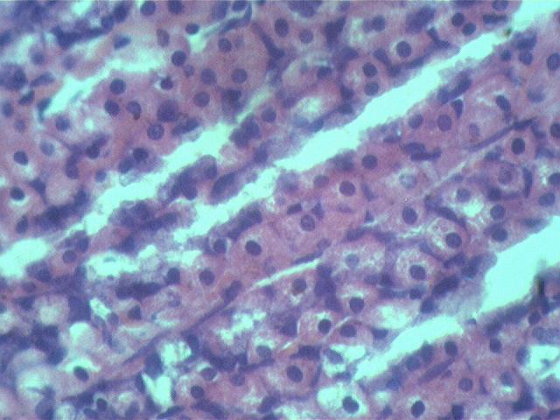
Figure 2: Section of ulcerated stomach of rats treated with RTLE (200mg/Kg b.w) in absolute alcohol induced ulcer model

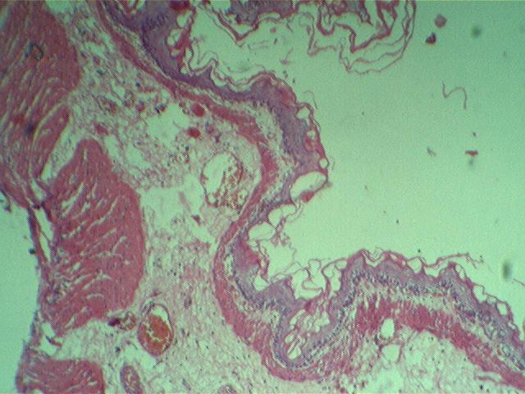
Figure 3: Section of ulcerated stomach obtained from rats of solvent control group treated with absolute alcohol

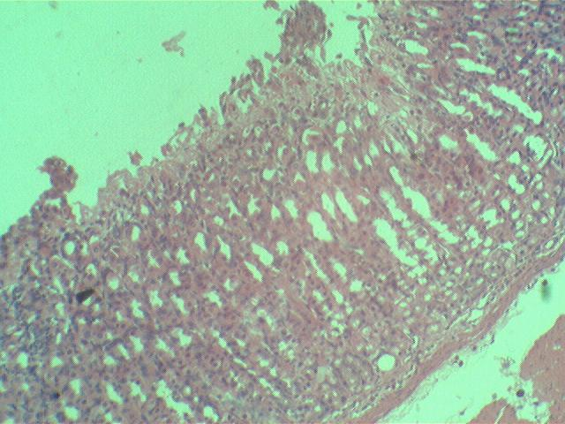
Figure 4 Section of ulcerated stomach of rats treated with RTLE (100mg/Kg b.w) in absolute alcohol induced ulcer model

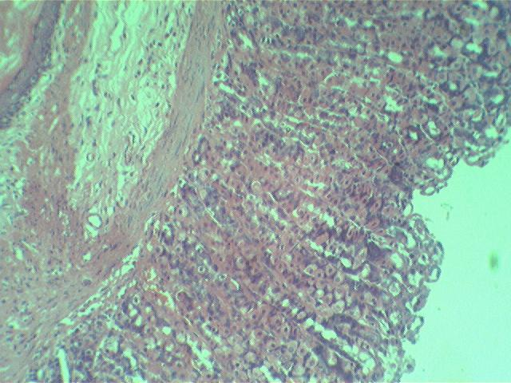
Figure 5: Section of ulcerated stomach of rats treated with Omeprazole(2mg/Kg b.w) in absolute alcohol induced ulcer model

ACKNOWLEDGEMENT
The authors are thankful to the Management and Principal of Dayananda Sagar College of Pharmacy, Bangalore for providing the facilities for the research work.

REFERENCES
1.Hahn K., Park I., Kim Y., Kim J., Cho S., Lee S., Young J., Role of rebamipide on induction of heat-shock proteins and protection against reactive oxygen metabolite-mediated cell damage in cultured gastric mucosal cells, Free Radical Biology and Medicine., 1997, 30, 22.
2. Czinner E., Hagymasi K., Blazovics A., Kery A., Szoke E., Lemberkovics E., The invitro effect of Helichysi flos on microsomal lipid peroxidation, J of Ethnopharmacol., 2001, 77: 31-35.
3. Yoshikawa T., Ueda S., Naito Y., Oyamada H., Morita Y., Yoneta T., Kondo M., Role of oxygen-derived free radicals in gastric mucosal injury induced by ischemia or ischemia reperfusion in rats, Free Radical Research Communications., 1989, 7, 285-291.
4. Bagchi D., Carryl O., Tran M., Krohn R., Bagchi D.J., Garg A., Bagchi M., Mitra S., Stohs S., Stress, diet and alcohol-induced oxidative gastrointestinal mucosal injury in rats and protection by bismuth subsalicylate, J of Applied Toxicology., 1998, 18 (Suppl 1) 3-13.
5. Gonzalez F., Portela T., Stipp E., Di Stasi L., Antiulcerogenic and analgesic effects of Maytenus aquifolium, Sorocea blomplandii and Zolernia ilicifolia, J of Ethnopharmacol., 2001, 77, 41-47.
6. Agro’s Dictionary of medicinal plants by Narayan Das Prajapati, U. Kumar, Agrobios ( India)., 288
7. Harborne J.B., Phytochemical methods, A guide to modern techniques of plant analyses, 2nd ed. Chagman and Hall New York, 1984, 120
8. Kokate C.K., Purohit A.P., Gokale S.B., Pharmacognosy, 7th ed, Nirali Prakashan, Pune, 2003, 105.
9. Umamaheshwari M., Ashok kumar, Rathidevi R., Antiulcer and antioxidant activities of Jasminum grandifolium, J of Ethnopharmacol., 2007, 110, 464-470
10. Gamez E.J.C., Luyengi L., Lee S.K., Zhu LF., Zhou B.N., Fong H.S., Pezzuto J.M., Kinghorn A.D., Antioxidative active principles isolated from Psidium guajava grown in Thailand, J Natural Products., 1998, 61, 706
11. Re R., Pelegrini N., Proteggente A., Pannala A., Yang M., Rice-Evans C., Free radical scavenging activity of extracts from Bulgarian veronica officianalis, Free Radic Biol .Med., 1999, 26, 1231-1237
12. Oyaizu M., 1986. Studies on products of browing reaction: Antioxidant activities of products of browning reaction prepared from glucoseamine, Japanese J of Nutrition., 1986, 44, 307-315
13. Sreejayan Rao M.N.A., Nitric oxide scavenging by curcuminoids, J of Pharmacy and Pharmacology., 1997, 49, 105-107
14. Mondalo S.K., Chakraborty G., Gupta M., Mazumdar U.K., Invitro antioxidant activity of Diospyros malabarica kostel bank, Indian J of experimental biology., 2006, 44, 39-44
15. Santra A, Chowdhury A, Chaudhari S., Oxidative stress in gastric mucosa in Helicobacter pylori, Indian J. Gasterol, 2000, 19: 21
16. Choi M.A, Kim B.S, Yu R., Serum antioxidative vitamin levels and lipid peroxidation in gastric carcinoma patients, Cancer Lett ., 1999, 136, 89-93
17. Prashanth K.V, Shashidhara S, Kumar M.M and Sridhar., Cytoprotective role of S. nigrum against gentamicin induced, Fitotherapia., 2001, 72, 481-486

*****

